**INSULIN INJECTION**

**Common injection sites**

The insulin must be injected into 1-2 inches of pinched skin.

Insulin is injected into the layer of fat directly under this skin, known as subcutaneous tissue.

It is injected with a small needle or a device that looks like a pen. There are several different sites where insulin can be injected, including:

**Abdomen**

The abdomen is a common site for insulin injection that many people with diabetes choose to use.

To give an injection into the abdomen, take a pinch of the fatty tissue from either side between the waist and the hipbones. It should be about [2 inches](https://www.drugs.com/cg/how-to-give-a-subcutaneous-injection.html) away from the belly button.

This site is easy to access, and some people report that it causes less discomfort than other sites.

**Upper Arms**

The upper arm is another site where insulin injections can be given.

The needle should be placed into the back of the arm (tricep area), about halfway between the elbow and the shoulder.

The main disadvantage of this site is that it is very difficult to use for self-administration and may require somebody else to do it. It may be more comfortable to inject into the non-dominant arm.

This means injecting into the left arm of a right-handed person or the right arm of a left-handed person.

**Thighs**

The thigh is also a very easy area for self-injection.

When using the thigh, insert the needle into the front of the thigh, halfway between the knee and the hip. It should be slightly off-centre towards the outside of the leg.

It is important to inject the medicine into a pinch of at least [1-2 inches](https://www.drugs.com/cg/how-to-give-a-subcutaneous-injection.html) of skin.

Though easy to access, regular injection of the thigh can sometimes cause discomfort when walking or running.

**Lower back or hips**

The final place that an insulin injection can be administered is the lower back or hip.

To administer an injection here, draw an imaginary line across the top of the buttocks between the hips.

The needle should be placed above this line but below the waist, about halfway between the spine and the side.

Like the upper arm, this site is very difficult to use for self-injection.

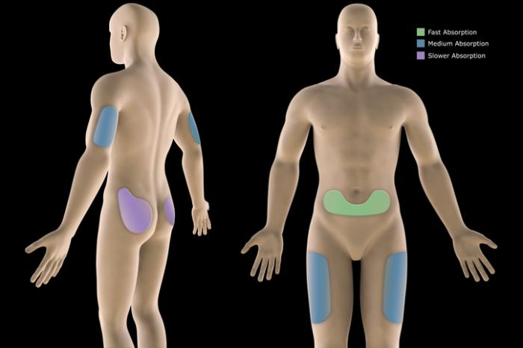

**Insulin absorption**

The speed of insulin absorption depends on the location of the injection - in the upper arms, abdomen, lower back, or thighs.

Insulin is absorbed differently from each of the different sites. This information can be used when planning insulin injections:

**Abdomen:** insulin enters the bloodstream most quickly.

**Upper arms:** moderate absorption speed but not as fast as the abdomen.

**Lower back and thighs:** slowest absorption speed.

It is best to administer rapid-acting insulin into the abdomen right after a meal. This is because it will be absorbed the quickest from here.

Long-acting and intermediate acting insulin can be administered into the other sites, like the arms, thighs, or hips.

The insulin works more efficiently over the entire time it needs to because of the slower absorption rate.

Exercise can increase the absorption rate of insulin and should also be considered when planning injections.

For example, a baseball pitcher should avoid injecting into their throwing arm. This is because the activity can affect how the insulin is absorbed into the body.

If planning to exercise a part of the body that is near the injection site, it is important to wait to for at least 45 minutes after the injection.

**Rotating injection sites**

It is important to avoid injecting the same site each time you inject. Reason being the muscles harden, this leads to poor absorption.